**FINAL -EXAM- PRATICAL -IOT LAB**

**NAME - SHUBHAM BAWANKAR**

**UID - 20BCS7409**

**DATE - 13/5/2021**

**PROJECT :**

**AIM:**

**Develop a smart phone application for smart home voice-assistant.**

**Requirements:**

*PC with Arduino*

*Connecting Wires*

*Breadboard*

*DOIT ESP32 DEVKIT V1*

*10uF Electrolytic Capacitor*

*Wire Clipper*

*USB Type A to Micro USB Cable*

*DC 5V Power Supply*

*DC 3.3V Power Supply*

*5v Relay*

*Light Bulb*

*AC Plug (Male)*

**EXPLAINATION :**

**A smart home refers to a convenient home setup where appliances and devices can be automatically controlled remotely from anywhere with an internet connection using a mobile or other networked device. Devices in a smart home are interconnected through the internet, allowing the user to control functions such as security access to the home, temperature, lighting, and a home theatre remotely.**

**Circuit Diagram:**

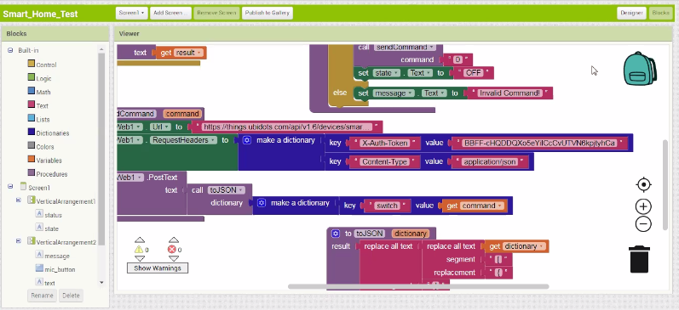

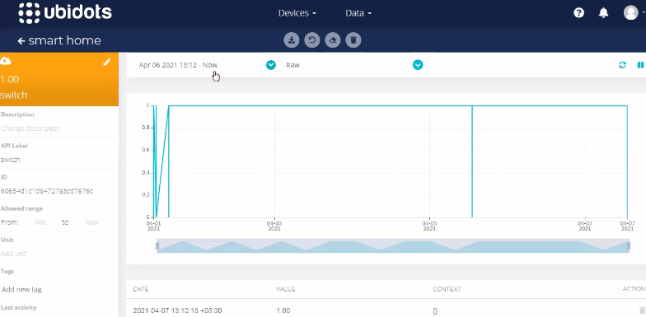

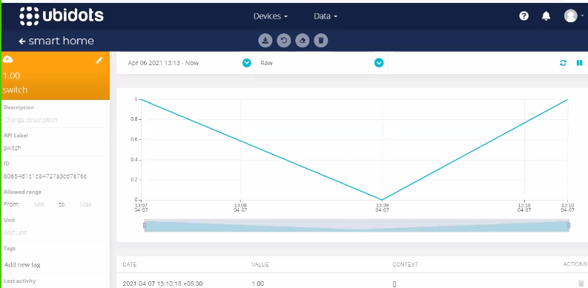

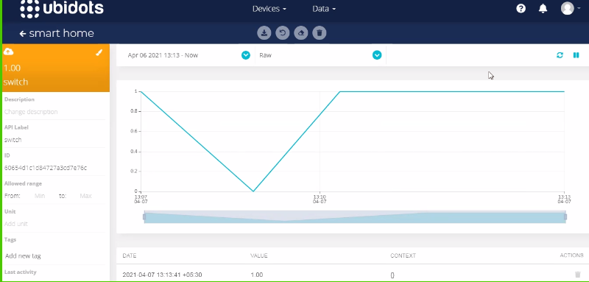

**Code:**

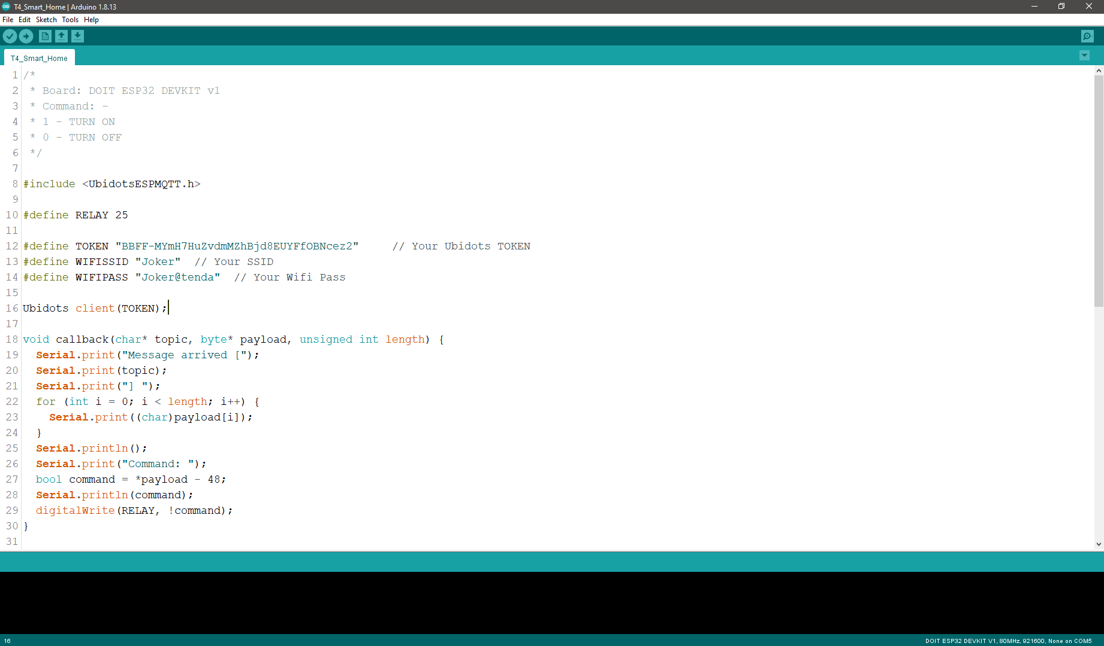

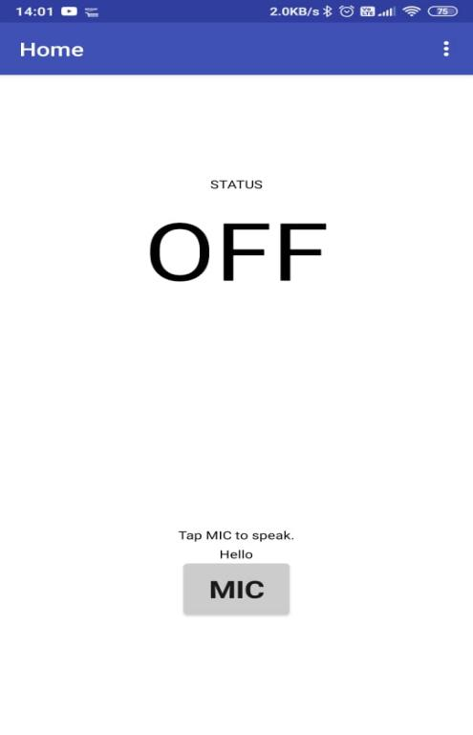

**Outcome:**

* Establish an interface between embedded IoT system and the physical world through sensors, to read the state of the world, and actuators, to change the state of the world.
* Design an appcessory with Bluetooth/Wi-Fi connectivity using standard mobile application development tools.